|  |  |
| --- | --- |
|  |  |
| Smart Exploration Research Centre  info@smartexploration.se | 20.06.2025 no 1-4/25-1014 |

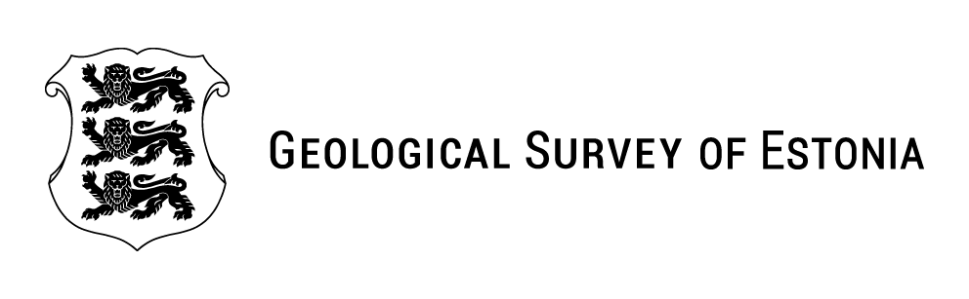Letter of Support

The Geological Survey of Estonia (EGT) would like to become a supporter of the multidisciplinary research centre Smart Exploration Research Centre (SERC), coordinated by Professor Alireza Malehmir, Department of Earth Sciences, Uppsala University, Sweden. This initiative aims to integrate the Geological Surveys of the Nordic and Baltic States and to foster cross-border collaboration in the exploration of critical raw materials.

As the national geological survey, EGT is responsible for mapping Estonia’s geology and disseminating geological data to meet societal needs for foundational geological knowledge, thereby supporting sustainable economic development. The centre’s research focus aligns closely with several of EGT’s ongoing initiatives related to strategic raw materials, innovation, and big data.

There is a pressing need for research in the proposed areas, and the establishment of SERC would provide a centralized hub for researchers to collaborate and exchange ideas. EGT is prepared to host researchers from the centre and its partner institutions to facilitate scientific and data exchange. Furthermore, we commit to contributing our expertise and experience through active collaboration in research projects associated with the centre.

Sincerely

Sirli Sipp Kulli

Director of Geological Survey of Estonia